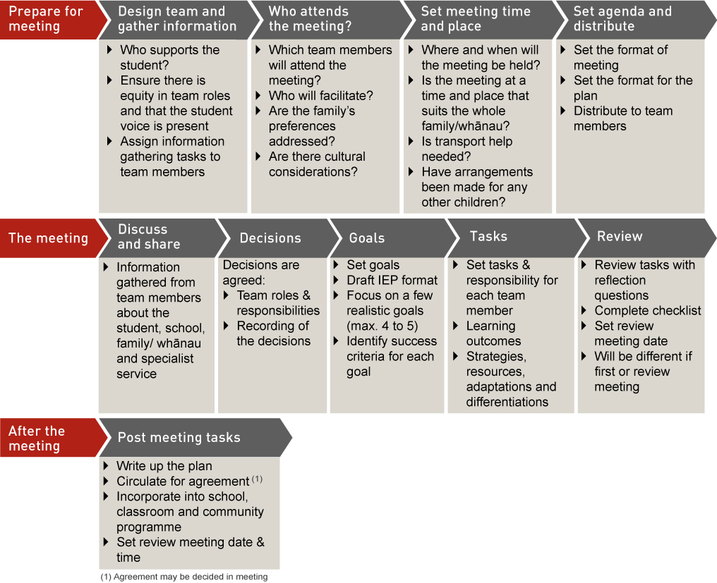
Prepare for meeting
  Design team and gather  information | Who attends the meeting? | Set meeting time & place | Set agenda & distribute
  - Who supports the student?  - Ensure there is equity in team roles and that the student voice is present  - Assign information gathering tasks to team members | - Which team members will attend the meeting?  - Who will facilitate?  - Are the family’s preferences addressed?  - Are there cultural considerations? | - Where and when will the meeting be held?  - Is the meeting at a time and place that suits the whole family/whānau?  - Is transport help needed?  - Have arrangements been made for any other children? | - Set the format of meeting  - Set the format for the plan  - Distribute to team members
The meeting
  Discuss & share | Decisions | Goals | Tasks | Review
  - Information gathered from team members about the student, school, family/whānau and specialist service | - Decisions are agreed:  - Team roles & responsibilities  - Recording of the decisions | - Set goals  - Draft the IEP format  - Focus on a few goals (max. 4 to 5)  - Identify success criteria for each goal | - Set tasks & responsibility for each team member  - Learning outcomes  - Strategies, resources, adaptations and differentiations | - Review Tasks with reflection questions  - Complete checklist  - Set review meeting date  Will be different if first or review meeting
After the meeting
  Post-meeting tasks
  - Write up the plan
  - Circulate for agreement⁽¹⁾
  - Incorporate into school, classroom and community programme
  - Set review meeting date & time
  (1) Agreement may be decided in meeting

